Vocab Chapter 12 Romantic Period 1820-1850

1. A La Chinoise (Hairstyle) - Hannah Ferreira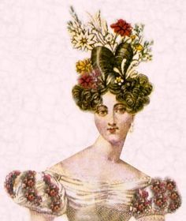

In about 1829, this hairstyle was created by pulling back and side hair into a knot at the top of the head, while hair at the forehead and temples was arranged in curls. These were not always just knots, they were also loops, curls, braids, and the hair in the front could also be left in sausage curls that laid in rows.

Book

<https://fashionhistory.fitnyc.edu/1830-1839/>

<https://ellie-valsin.tumblr.com/post/114139741561/hairstyles-and-hats-ca-1830-part-1>

1. Bavolet - Lauren Shumway

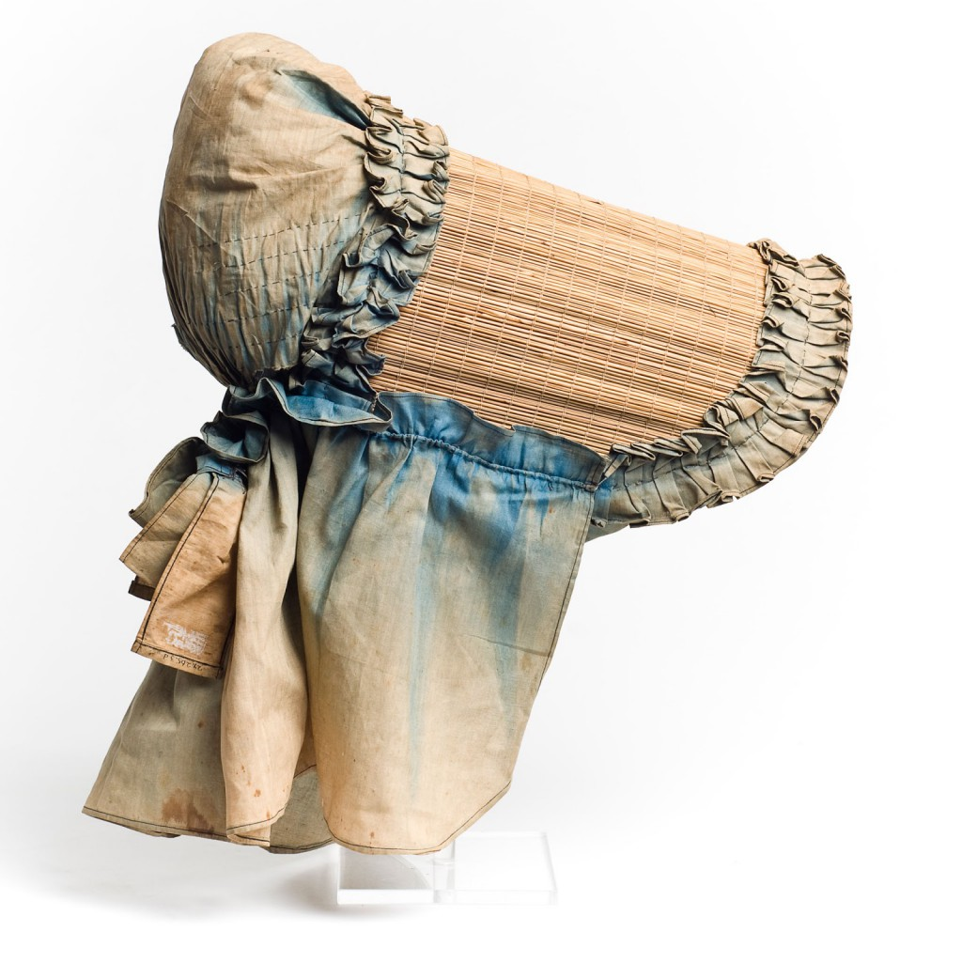

A piece of fabric attached to the back of a bonnet to protect the back of the neck from the sun. Often made with quilted cotton and linen. The bavolets where wore by both upper and lower classes of women of all ages

The Book p.338

<https://www.charlestonmuseum.org/news-events/hats/>

<https://annaworden.com/2014/02/28/understanding-the-ribbon-bavolet/>

1. Beak (waistcoat) - Debbi Wright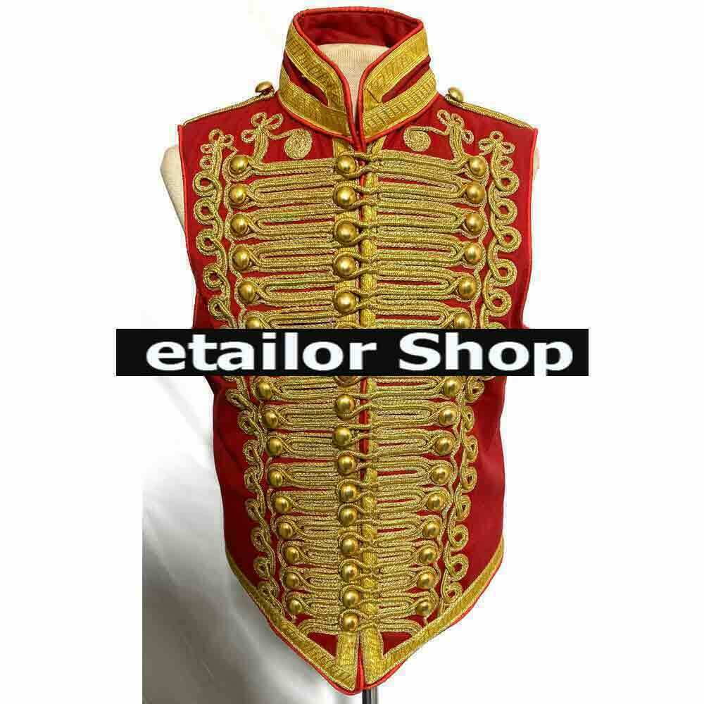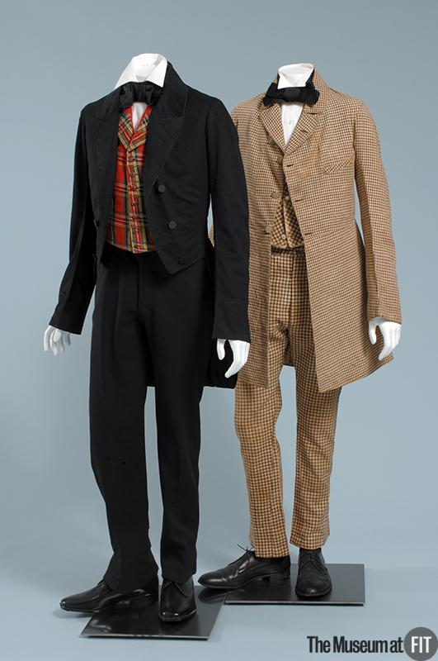

This is a waist coat that was developed to include the point at the bottom center of the jacket. The first example is just for a better view of the “beak” at the bottom of the vest. The second example with the dark suit is what the “beak” or “Hussar front” would have looked like on the waistcoat. According to our textbook it also tells us that the lapels were narrower and curved less. At the end of the 1840s the lapels were wide again and sometimes they were worn over coat collars and lapels. The waistcoats worn in weddings were usually white or cream in color. Evening coats would often be made of silk satin, velvet, and cashmere.

Toratora, Phyllis G, and Keith Eubank. *Survey of Historic Costume, 5th Edition*. Berg, 2009

<https://www.google.com/search?q=hussar+front++or+beak+waistcoat+1840-1850&hl=en&sxsrf=APq-WBs_L0xTLhzqmmS4IDJZKoUZVt2J7w:1645554856092&source=lnms&tbm=isch&sa=X&ved=2ahUKEwi0iJ_F-ZP2AhXhIUQIHQoZDqsQ_AUoAnoECAEQBA&biw=1366&bih=625&dpr=1#imgrc=xoTnAZMaYibRuM>

<https://www.ebay.com/itm/144420070944?chn=ps&var=443724678781&norover=1&mkevt=1&mkrid=711-117182-37290-0&mkcid=2&itemid=443724678781_144420070944&targetid=1263094004306&device=c&mktype=&googleloc=1027744&poi=&campaignid=14859008593&mkgroupid=130497710760&rlsatarget=pla-1263094004306&abcId=9300678&merchantid=433595636&gclid=CjwKCAiAsNKQBhAPEiwAB-I5zVPApGJNKvOJudHE9byenDTewMjJS9J2U3iSnNhz8xlil73hf18lrRoCeFQQAvD_BwE>.

1. Bertha - Abby Fluckiger

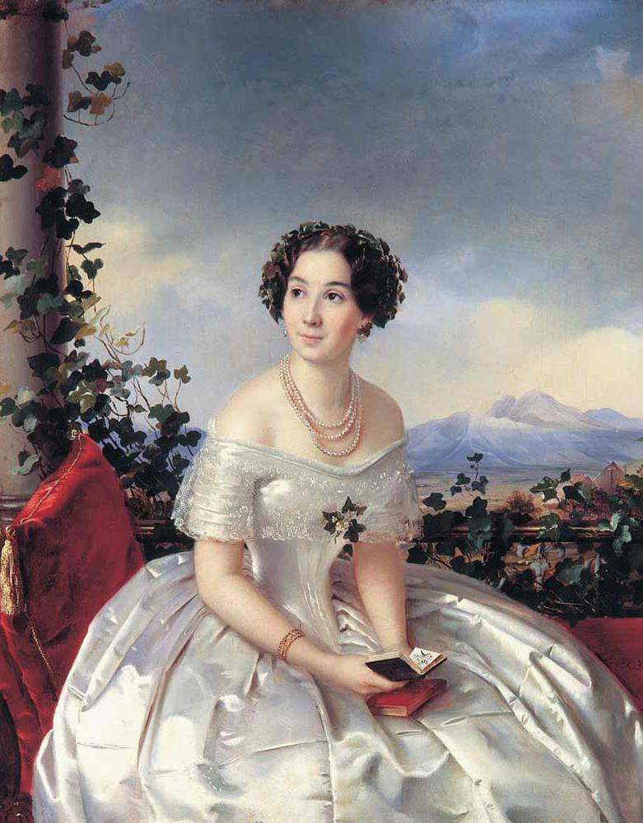 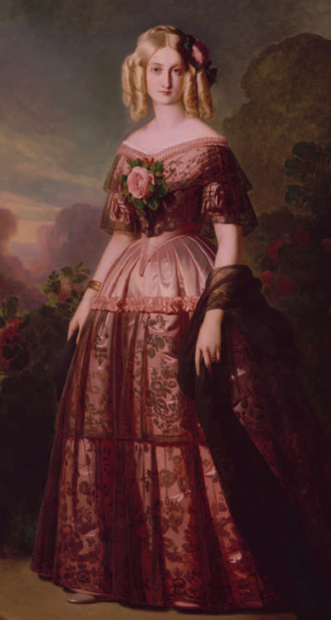 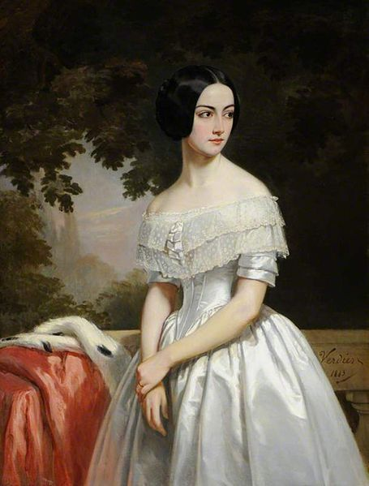

The bertha collar was a wide, flat, semicircular panel of fabric or lace that followed the wide necklines of popular fashions in the Romantic period. They could be wide enough to hide the sleeves, especially in shoulder-point or off-the-shoulder styles, or be farther up on the décolletage. They emphasized the width of the shoulders and the narrow waist fashionable at this time.

Sources:

Textbook, page 335, 339

<https://trc-leiden.nl/trc-needles/individual-textiles-and-textile-types/daily-and-general-garments-and-textiles/bertha>

<http://bloshka.info/2020/09/30/bertha-collar/>

1. Bishop Sleeve - Ida Johnson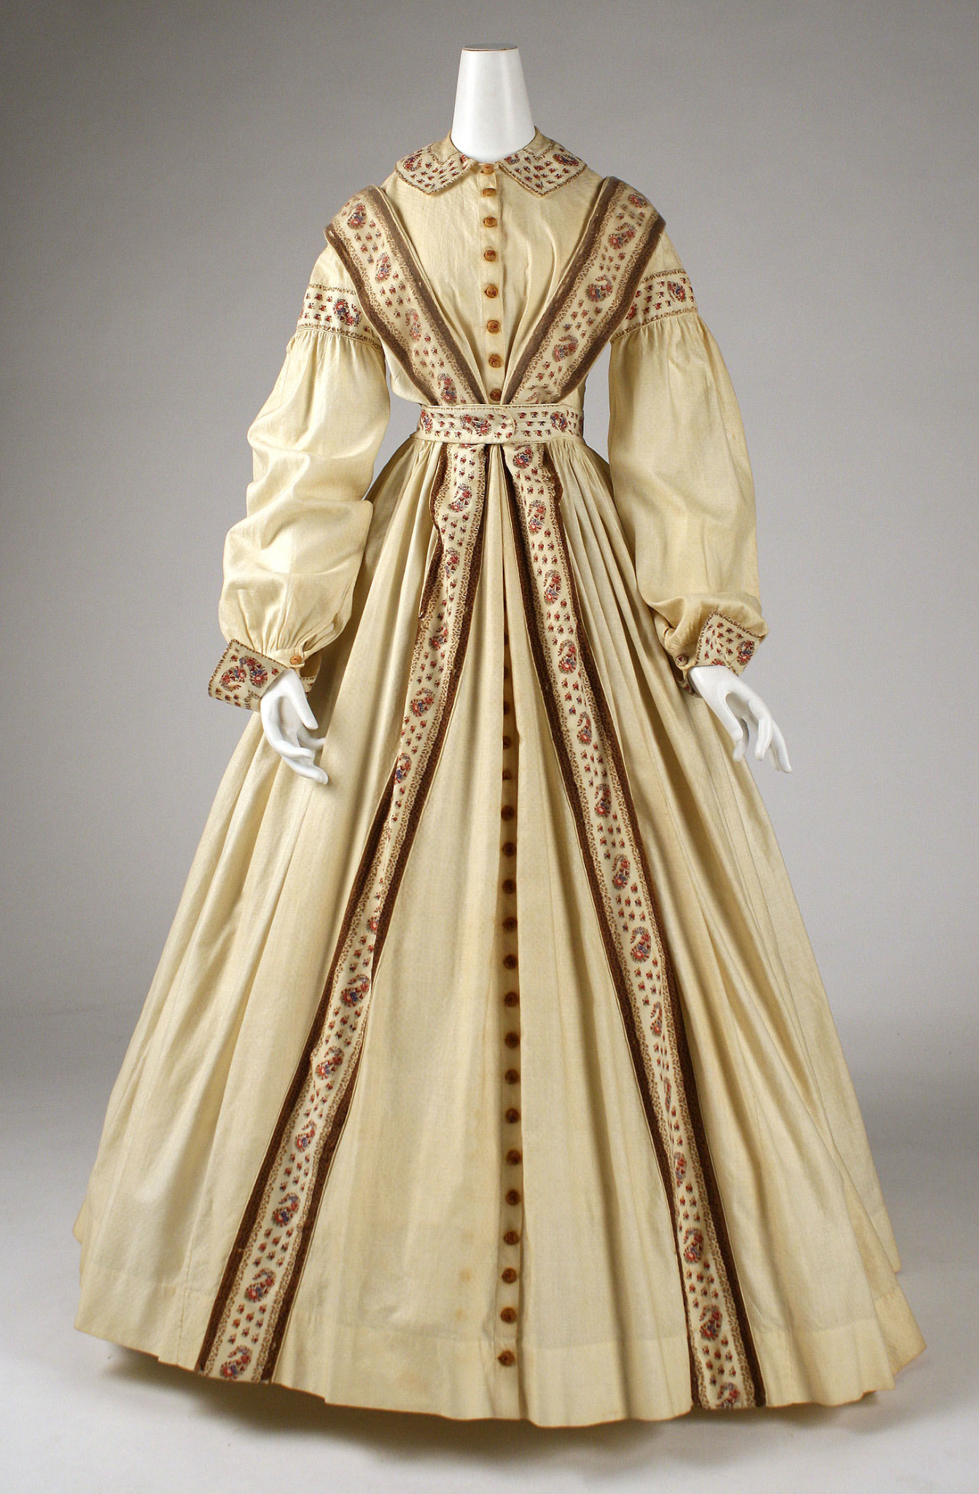

Made with a row of vertical pleats at the shoulder that are released into a soft, full sleeve gathered at the wrist into a full cuff. Pg 336 <https://genealogylady.net/2015/07/26/fashion-moments-bishop-sleeve/> <https://www.metmuseum.org/art/collection/search/80769>

1. Bonnet: Lexie Pincock

A type of hat worn by women. It was used as a piece to compliment a woman’s dress. An accessory that came in many shapes and designs. These were a part of fashion and were almost always worn.

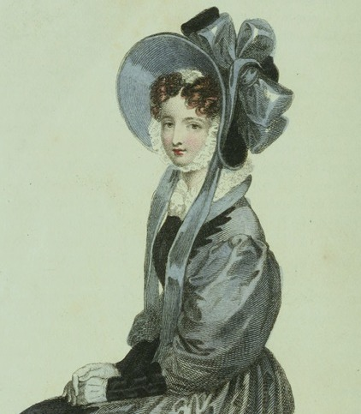

Sources:

Pg 330, 334-337

<https://historicalsewing.com/classes/romantic-era-poke-bonnet-class>

<https://fashion-era.com/romantic_era.htm>

1. Bowler- jamie rakes

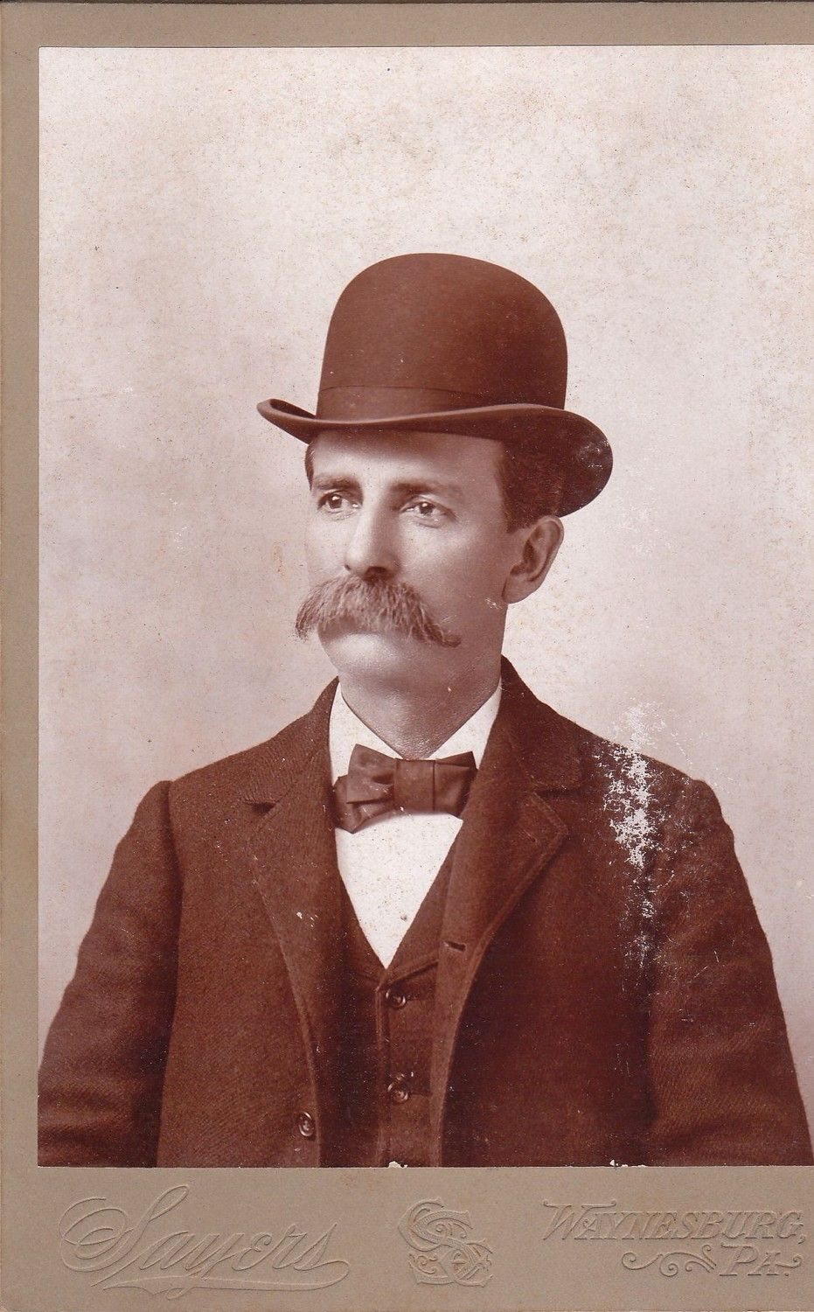

The bowler was a hat that was commonly worn by men during the romantic period. The bowler hat was also called the derby hat. Derby hat was usually the term used to describe the hat in America while Bowler was the term used in Europe. The hat originated in the lower working class but by the late 1800s it was adopted by all classes. It was a made out of a hard felt with a narrow brim and a rounded crown. It was first introduced in 1849 by British soldier and politician Edward coke.

<http://www.historyofhats.net/hat-history/history-of-bowler-hat/>

<https://www.levinehat.com/pages/whats-the-difference-between-a-derby-hat-and-a-bowler-hat>

Textbook pg 252

1. Box Coat-Abigail Storrer

A box coat was worn by men between 1820 and 1850. It was a type of great coat, which were coats worn outside. Except this one was very large and also included capes on the shoulder of the coat. These coats were also called curricle coats. A curricle back then was an open carriage drawn by two matching horses that wealthy people used. Later in the century, Carrick coats were used, which were like a box coat, but had multiple capes instead of just one, layered over each other. 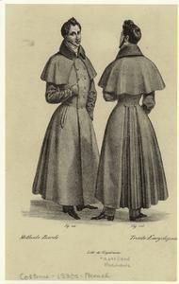

Tortora, P. G., & Eubank, K. (2010). *Survey of historic costume: A history of western dress*.

Fairchild.

<https://fashionhistory.fitnyc.edu/carrick-coat/>

<https://www.thecarriagefoundation.org.uk/item/curricle-%20maidstone>

Curricle Coat - Abbie Burns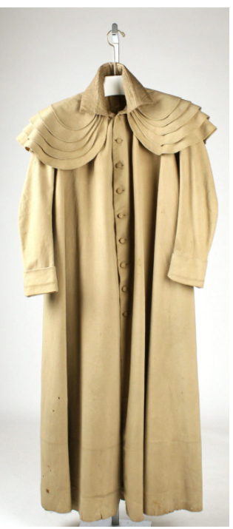

This is a box coat, it is large and typically worn by men to stay warm in the winter. It has 3-5 capes around the shoulder. Lapels were found at the bosom and sloped away going towards the back, with very long sleeves. Later on a similar coat for women came out called the "Duster coat".

Sources:

Book: Page 343

<https://fashionhistory.fitnyc.edu/carrick-coat/>

[(Links to an external site.)](https://fashionhistory.fitnyc.edu/carrick-coat/)

https://quizlet.com/52889010/ch-12-flash-cards/

1. Burnous - Jalissa Cloward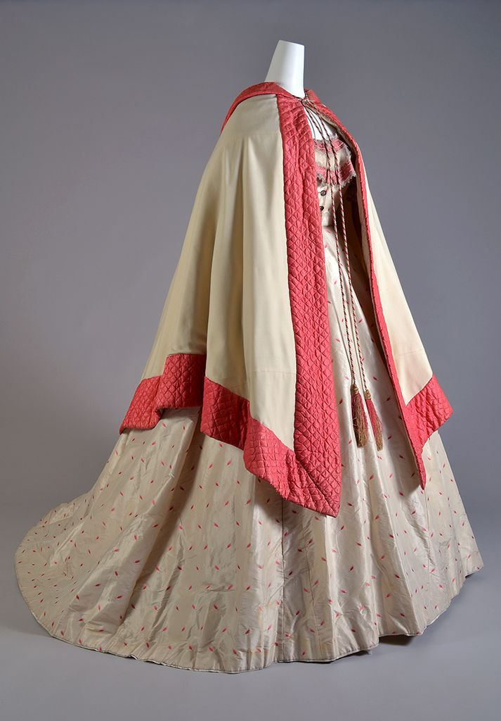

A burnous was a long mantle with a hood. It was normally about three quarters in length. It could be worn by both men and women, and people tended to wear it to important events. It is a style that came from the Arabs.

*Survey of Historic Costume* pg. 338

<https://thedreamstress.com/2012/05/terminology-what-is-a-burnous/>

<https://blinkhubs.com/romantic-period-in-fashion-history/>

1. Bustle - Irelynd Preece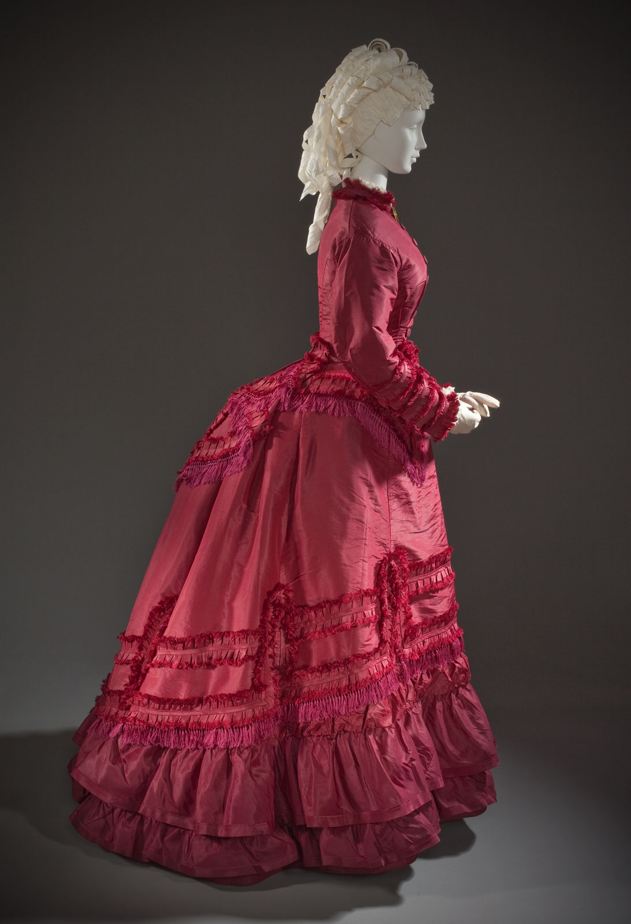

The bustle was an artificial hump or back pad that was “invented” to give the high-waisted line a graceful flow. Even as waists lowered and skirts widened, the bustle remained. They were tied on around the waist at the back. The bustle was made out of down or cotton filled pads. The bustle became popular because they were an answer to the “hoop” problem. Women found that with the hoop they couldn’t move freely so fashion moved the volume these women desired to the back of the dress.

Sources:

Textbook page 332

<https://www.azyaamode.com/en/did-you-know-hellip-why-women-wore-bustles->

<https://fashionhistory.fitnyc.edu/bustle/#:~:text=Even%20early%2Dnineteenth%2Dcentury%20neoclassical,it%20was%20called%20a%20bustle.%E2%80%9D>

1. Canezou - Kya Boyd

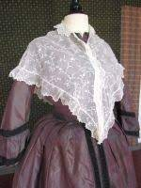

Canezou or fichu-canezou is a piece of clothing worn along with a corsage its origin is a short jacket similar to spencers. Over time they changed into a sleeveless, sideless form made with mainly white material. Even though spencers could be worn indoor and outdoor, when wearing one indoors as an evening Spencer it was considered a canezou. Women wear it over another layer of clothing, mainly dresses; the material of the canzou is normally light weight. In 1811 the canezou had sleeves, but as time passes it looks more like a scarf-like wear.

Sources:

<https://en.wikipedia.org/wiki/Canezou>

<https://fashion-era.com/fashion-history/regency/regency-fashion/>

<https://kittycalash.com/2017/08/02/au-courant-un-canezou/>

1. Capote- Hailey Child

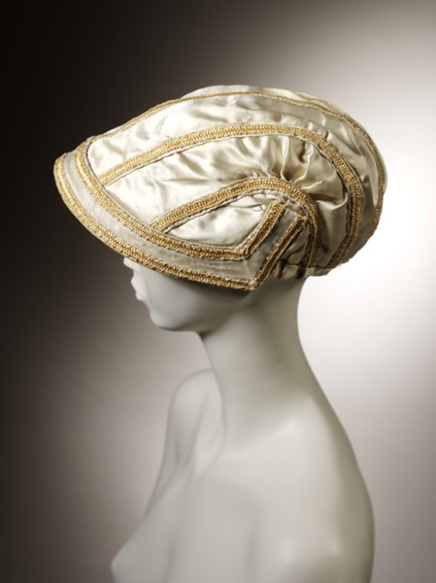

A capote is also considered a scoop shaped bonnet. This hat accommodated the styles of hair in this era of short hair piled on top of the head. Capotes were generally made to be worn outdoors. It was made with different patterns and colorings and in the early 19th century was used for evening headwear.

<https://janeaustensworld.com/2012/04/20/capote-bonnet-a-19th-century-hat/>

Book

<https://www.metmuseum.org/art/collection/search/113231>

1. Carriage Dress- Jessica Fraser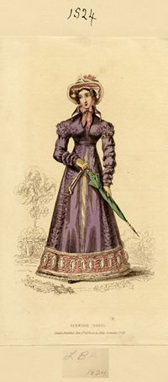

The carriage dress was a daytime dress. It was for simple strolling and wandering around. It had a high neck and covered the legs and arms. It fitted nicely at the waist. It was very conservative and meant for the daytime. Skirts were normally in A shape. Cotton was also a preferred fabric at the time. I thought it was interesting that the Queen Victoria video, how many layers she wore and that her clothes were embroidered with crowns and other symbols.

The Book

<https://lowelldesigns.com/romantic-early-victorian/https://lowelldesigns.com/romantic-early-victorian/>

<https://maggiemayfashions.com/calicoball/fashionhistory/the-romantic-era-1820-1850/>

1. Chatelaine - Alex Clark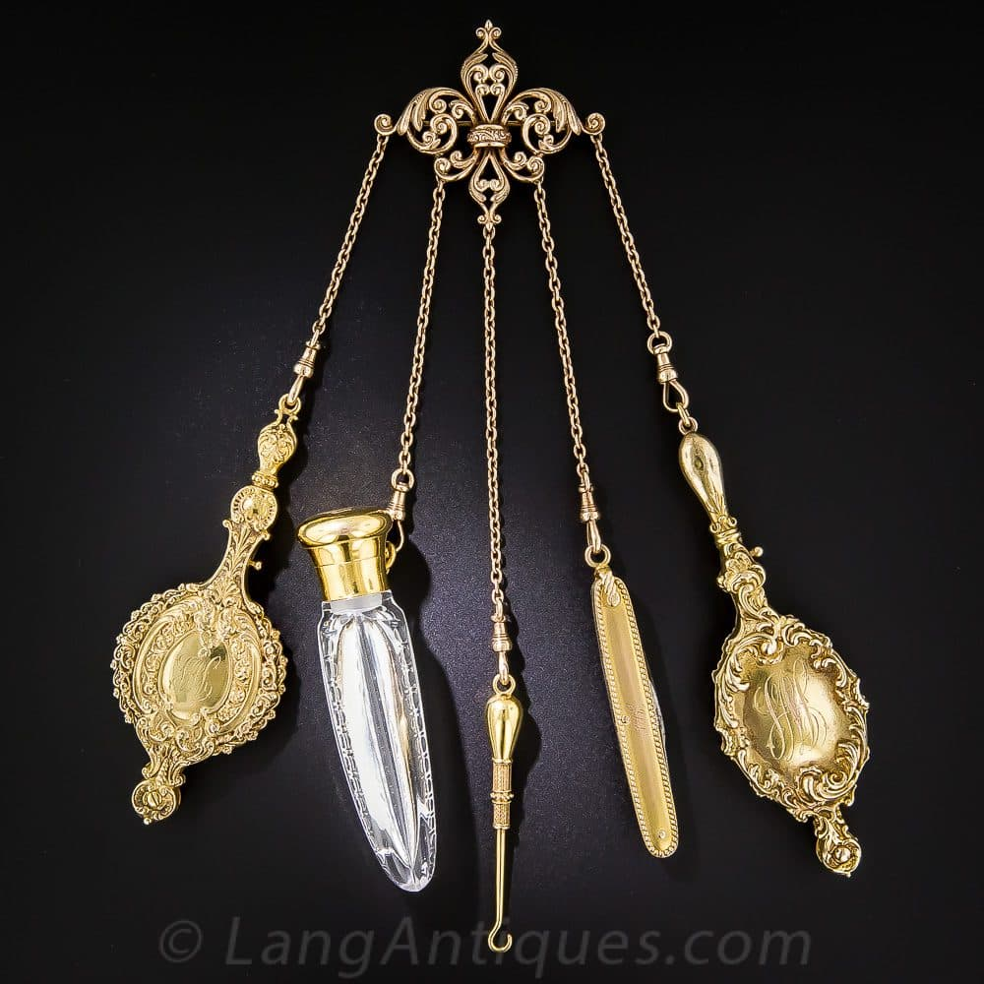

Chatelaines was an ornamental chain that were worn at the waist and suspended onto this chain were a multitude of items such as scissors, penknives, button hooks, and many other useful items. The making of these chains was made up of gold or a yellow alloy that was named pinchbeck. The chatelaines were decorated with biblical, mythological or genre scenes, or they were inlaid with gemstones in order to decorate them.

Survey of Historic Costume, Page 340

<https://www.britannica.com/art/chatelaine>

<https://en.wikipedia.org/wiki/Chatelaine_(chain)>

https://www.langantiques.com/university/chatelaine/

1. Chemisette- Bailey Pinder

Chemisettes were also called fillers or tuckers. They were made to raise the neckline of a daytime dress. They were separate front the dress and could be worn with different bodices. Chemisettes were sleeveless and usually made of muslin, linen, cotton, or lace.Some chemisettes were meant to tie around one’s waist while others were tucked into the skirt or pinned to the clothing underneath. They had the additional benefit of being able to be worn with any number of gowns further expanding the wardrobe.

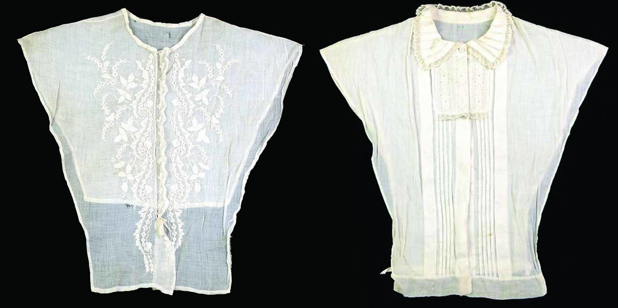

<https://fashionhistory.fitnyc.edu/chemisette/>

<https://janeausten.co.uk/blogs/womens-regency-fashion-articles/the-chemisette>

Survey of Historic Costume page 334

1. Chesterfield-Anna Ament
2. Cravat
3. Curricle Coat
4. Day Dress - Jensen Stenquist

Day dresses were also called promenade or walking dresses and sometimes called carriage dresses. Day time dresses were known for having lower waistlines, wide sleeves, and full skirts that fasten either in the front or in the back. Necklines varied, with many being v-shaped. Some necklines were high, ending at the throat, and finished off with a small collar or ruff. The influences of Romanticism brought forth fashion trends from the past- such as neck ruffs, slashing.

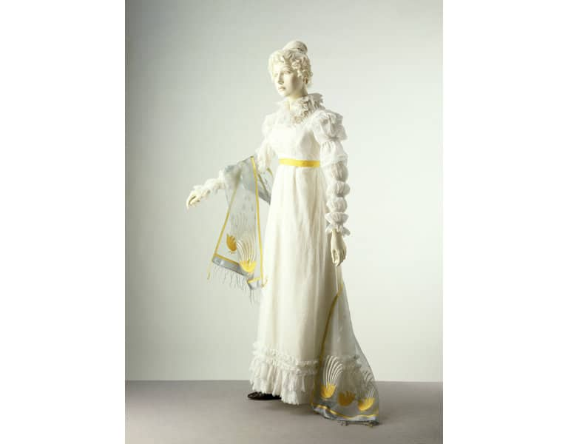

<https://maggiemayfashions.com/calicoball/fashionhistory/the-romantic-era-1820-1850/>

<https://fashionhistory.fitnyc.edu/1820-1829/>

Survey of Historic Costume, Page 332

1. Demi-gigot Sleeve

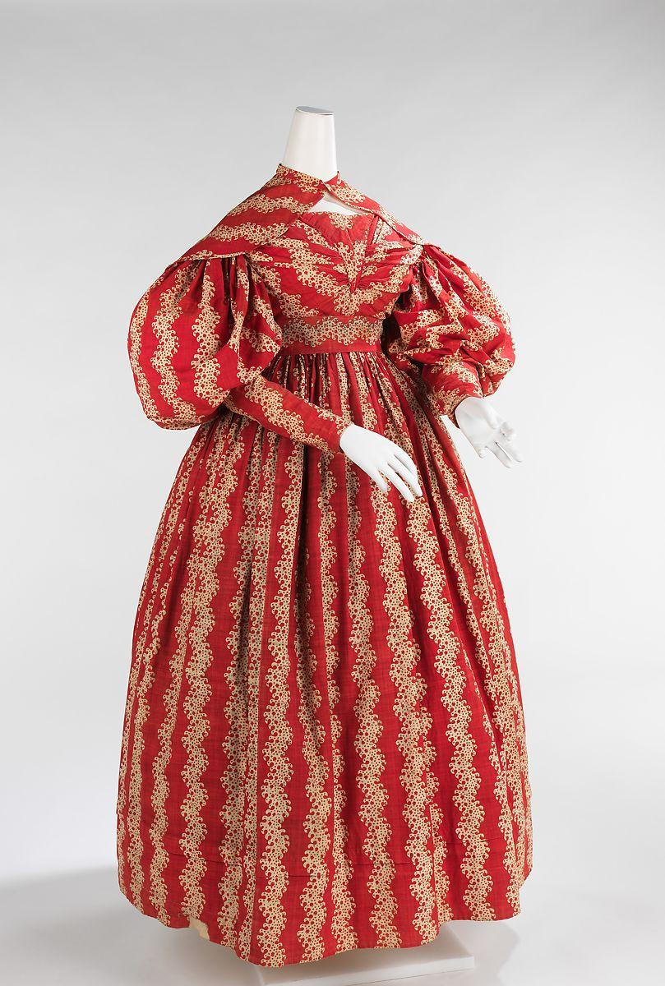

Demi-Gigot Sleeves were very similar to the Gigot or leg-of-mutton sleeve in that they were very full. However, demi-gigot sleeves were only full from the shoulder till the elbow, they were then fitted down to the wrist. Many times the sleeves had some sort of boning or filling to help keep the puffed shape.

https://www.metmuseum.org/art/collection/search/159535#:~:text=Dress%201832%E2%80%9335&text=The%20large%20gigot%20sleeves%20were,by%20whalebone%20or%20down%20filling.

https://fashionhistory.fitnyc.edu/gigot-sleeve/

Tortora, P. G., & Marcketti, S. B. (2021). In Survey of historic costume. essay, Fairchild Books.

1. Derby Hat 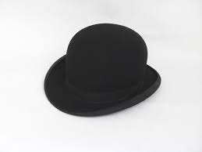Lena Kawakami a derby hat is the American name for the hat and a bowler hat is the British name for the hat, it is the same thing, this kind of hat was first made for Edward coke who was a soldier and politician at the time he ordered the hat from a place called hatters lock at co and this kind of hat was made because when men rode horses they used to wear top hats and when they would hit branches while riding their hats fell off this hat was a kind of protective, more helmet like and protected the rider better <https://fashionablehats.com/blogs/hat-articles/bowler-hat-vs-derby-hat> <http://www.historyofhats.net/hat-history/history-of-bowler-hat/>
2. Drawn Bonnet

[Source 1](https://maggiemayfashions.com/1840s-1850s-drawn-bonnet/) [Source 2](https://annaworden.com/2018/12/20/anatomy-of-a-drawn-bonnet/) Pge

1. Dressing Gown - Kimberly Tesam Moita

The Dressing gown was still worn by men and the style didn’t change much from the Empire period. Men wore these long robe-like coats or tunics at home mainly in the morning, and at night. Dressing gowns also sometimes had matching waistcoats, and so the sets were acceptable to wear outside, as opposed to the robes and nightwear of today. The dressing gowns were made of decorative damask, wool, silk, or cotton. It was also still called a banyan and had middle eastern influenced style choices like mandarin necklines and closures. But, they did start to take on some differences; the example shown below is of a more coat-like dressing gown, with a matching waistcoat and stocking cap.

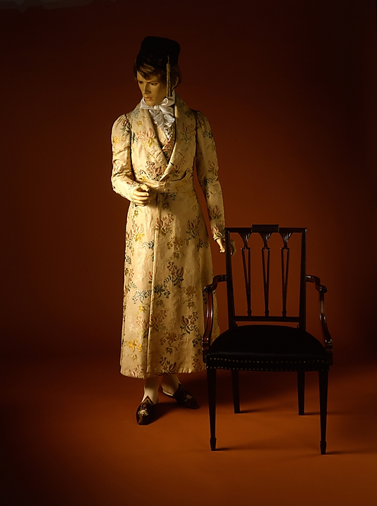

<https://fashionhistory.fitnyc.edu/1820-1829/>

<https://lowelldesigns.com/romantic-early-victorian/>

<https://maggiemayfashions.com/calicoball/fashionhistory/the-romantic-era-1820-1850>/

1. En coeur (neckline) - Claire Lynes

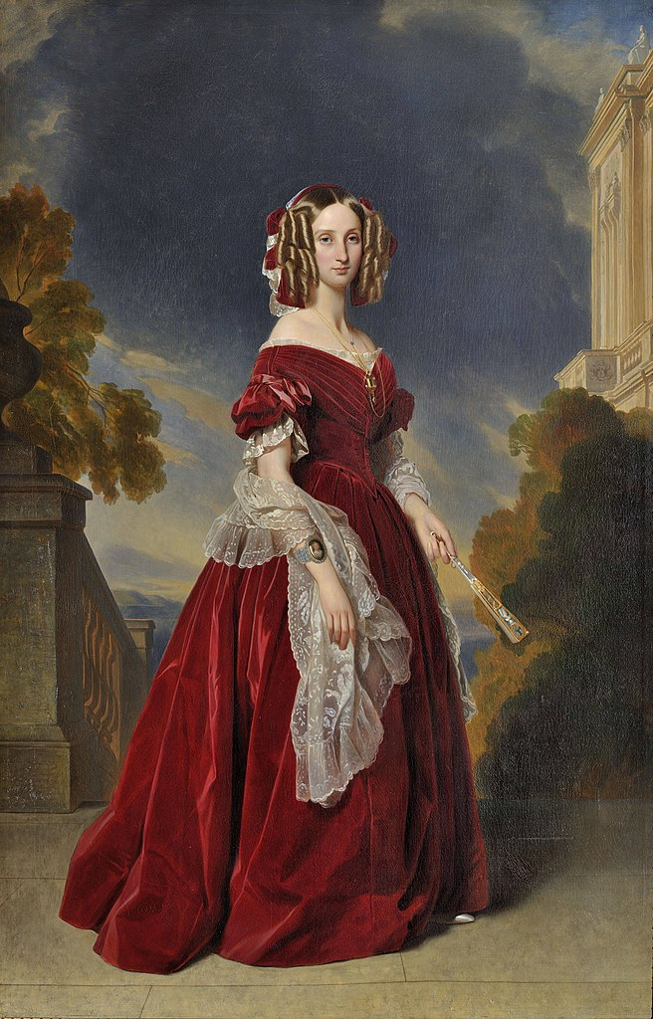

The En Coeur neckline is an off the shoulder neckline that dips down at center front. Similar to our sweetheart necklines. But the En Coeur neckline had a soft point instead of a drastic point. The En Coeur neckline was often very low cut.

<https://fashionhistory.fitnyc.edu/1840-1849/>

<https://aisleadressthehistory.wordpress.com/2017/05/03/the-romantic-period/>

Survey of Fashion History Costume Book

1. Eton Suit - Savannah Jeppson

The Eton Suit was a suit worn by young boys and was derived from an English School boys uniform, coincidentally named Eton School. This style, with basic variations, remained for the rest of the century for young boys.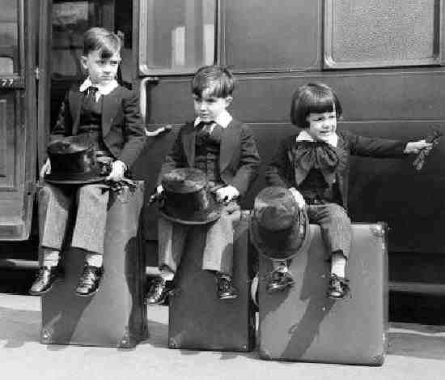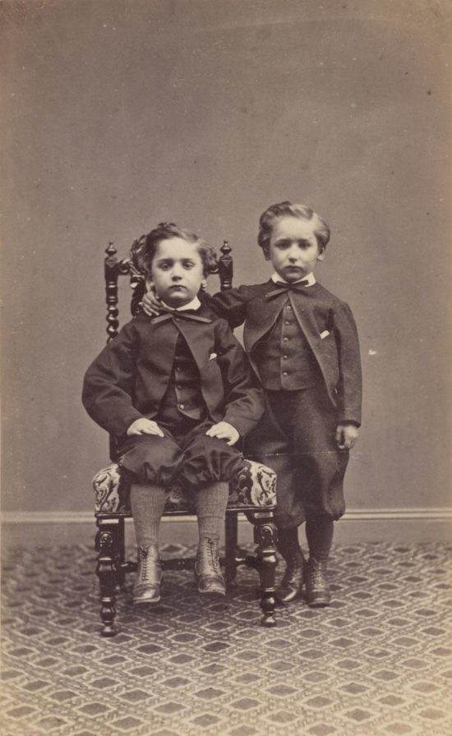

Sources:

<https://www.thehenryford.org/collections-and-research/digital-collections/artifact/344491/#slide=gs-256560>

<https://maggiemayfashions.com/calicoball/fashionhistory/the-victorian-era-crinoline-period-1850-1869/>

Survey of Fashion History Costume Book

1. Fichu Pelerine
2. Galoshes
3. Gigot Sleeve : Elizabeth Nathan

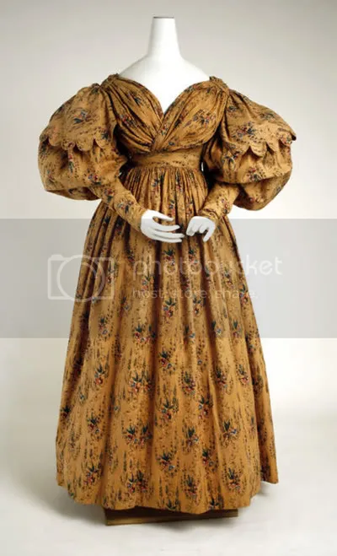

Big sleeves began to come into fashion in the late 1820s, but really hit their stride in the 1830s. Called leg-of-mutton or gigot sleeves (the French translation of leg-of-mutton), they started slightly off the shoulder and puffed out before narrowing again towards the lower arm. In combination with the popular V-neckline and full skirt, gigot sleeves helped to give an illusion of a narrower waist.

<http://www.thefashionhistorian.com/2011/03/gigot-sleeves.html>

[(Links to an external site.)](http://www.thefashionhistorian.com/2011/03/gigot-sleeves.html)

<https://fashionhistory.fitnyc.edu/gigot-sleeve/>

1. Gilet corsage: Madison Frost

Is a french word for a women's jacket made out of a mens waistcoat. Gowns in this era were typically made in one piece, however this would be worn on the top.

1. 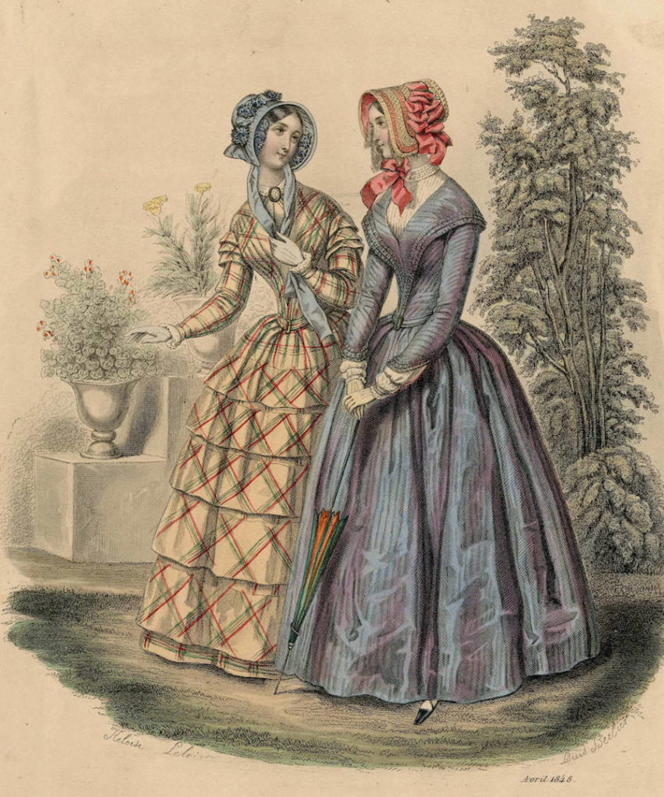
2. Imbecile, Idiot Sleeve- Andrea Lazaro

The Imbecile or Idiot Sleeve were puffy sleeves that went down from the shoulder to the elbow and then tightened from the elbow to the wrist. The name comes from the similarity these sleeves have to straight jackets worn by mentally unstable patients.

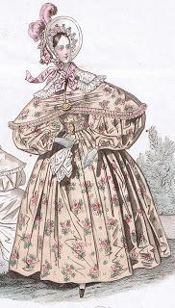

Sources:

https://www.irenebrination.com/irenebrination_notes_on_a/2016/08/sleeve-designs.html

https://www.pinterest.com/pin/757660337280867350/

1. Jeanette Sleeve
2. Leg-of-Mutton Sleeve
3. Mackintosh Coat
4. Mantlet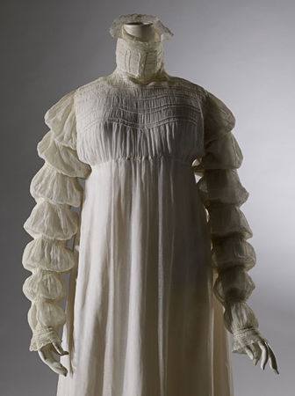
5. Marie Sleeve- Samantha Hooper

The Marie sleeve was a style of sleeve that was loose at the wrist, but tied with ribbons or bands up the sleeve in intervals.

1. Morning Dress
2. Negro Cloth - Marisa Bone

A negro cloth was a coarse and strong cloth used for slaves clothing in the west indies and southern colonies. It was a sharp woven material made of cotton or blended coarse threads also homespun. They were inexpensive and most were very uncomfortable. One freed from slavery recalled the feeling of the cloth to be "Needles stiching one all the time."

[Source 1](https://en.wikipedia.org/wiki/Negro_cloth) [Source 2](https://digitalcommons.unl.edu/cgi/viewcontent.cgi?article=1739&context=tsaconf) History of Fashion Book

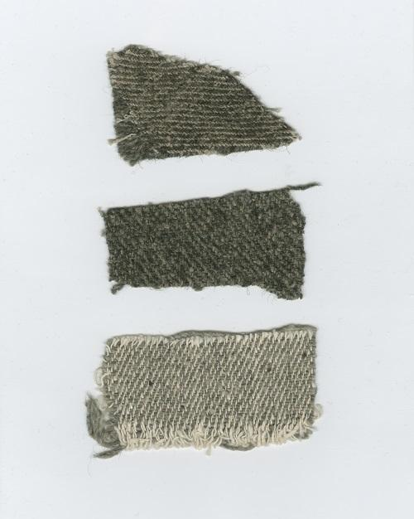

1. Newmarket
2. Paletot (men’s) - Aubrey Reidhead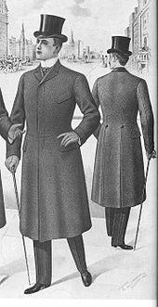

The Paletot is a man’s overcoat that is just about knee length and has slits for the arms to go through. The coat has varied in specific styling, but it was typically a fitted garment. Most had several flaps that gave the coat cape like features, if a cape wasn’t directly incorporated into it.

[Wiki](https://en.wikipedia.org/wiki/Paletot) [Art of Manliness](https://www.artofmanliness.com/style/clothing/mans-guide-overcoats/) Pg. 345

I also did the Bertha in the discussion board first, but I couldn’t access the google doc at the time.

1. Paletot (women’s)
2. Pardessus
3. Pelerine- Marisol Dejesus

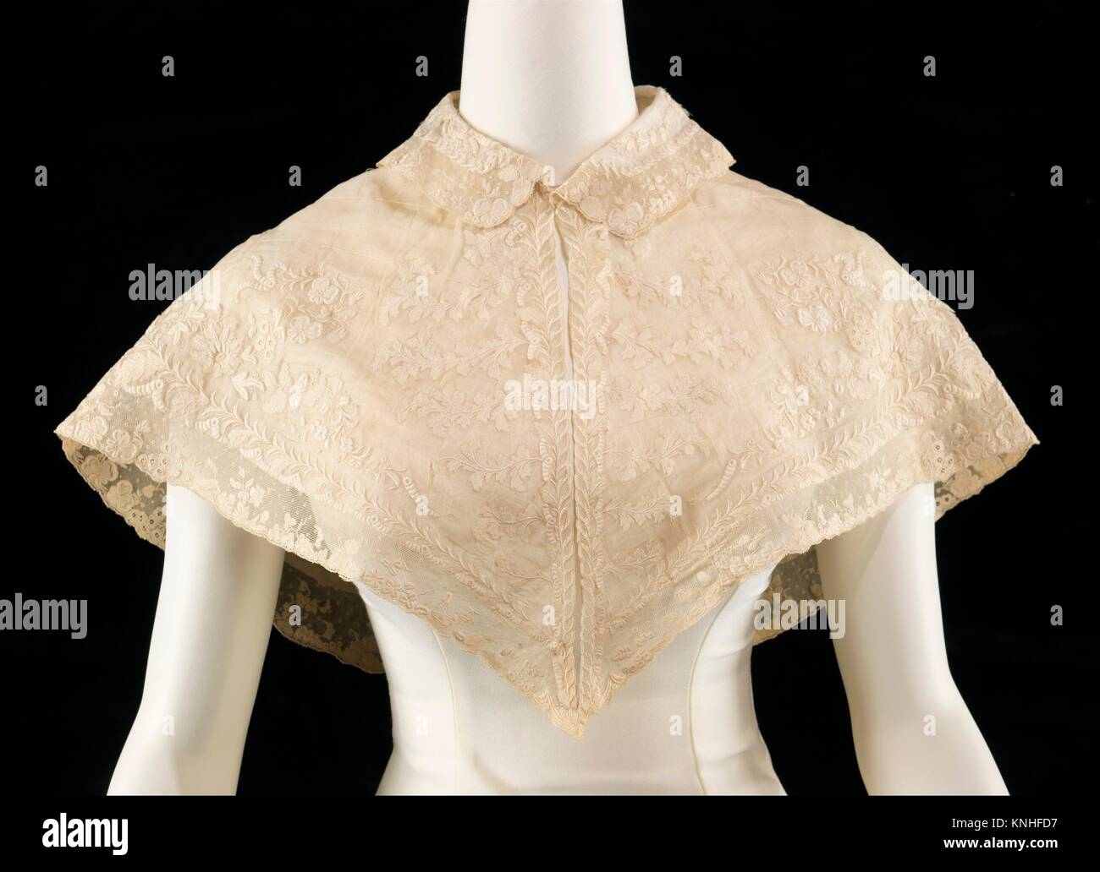

Pelerines are wide collars that extend over the shoulder and past the chest, similar to a cape. Pelerines are made of muslim, silk, cambric, and decorted or embriodery with lace. The term came from different regions, such as Italy and France.

<https://en.wikipedia.org/wiki/Pelerine#:~:text=A%20pelerine%20is%20a%20small%20cape%20that%20covers%20the%20shoulders.&text=Layered%20muslin%20pelerines%20were%20popular,the%20shoulderline%20of%20the%20decade>.

<https://mentalitch.com/the-history-of-the-pelerine/>

1. Pelisse-robe
2. Cartridge Pleating or Gauging
3. Pelerine Mantlet
4. Promenade Dress
5. Ruching
6. Santon
7. Shawl Mantlet
8. Sleeve en Bouffant
9. Sleeve en Sabot
10. Top Hat- Savannah Tanner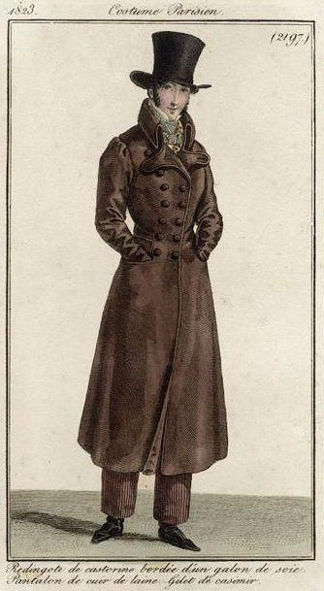

The top hat was often seen as day and evening wear. The top hat had many different styles depending on the shape. The crown of the hat and the brim could vary in height and width. The Gibus hat was collapsible for evening wear. Top hats had small brims. Top hats were often made of silk and were considered very fashionable. Top hats were nicknamed stovepipes as they grew in size over the centuries.

<http://www.fashionencyclopedia.com/fashion_costume_culture/European-Culture-19th-Century/Top-Hat.html>

http://www.victoriana.com/Mens-Clothing/tophats.htm

Pg. 344

1. Trousers - Zaya

Trousers were a bifurcated leg garment that were full length as opposed to knee length of breeches. They replaced breeches as daily wear by about 1840. Breeches at this time were limited to full dress & sportswear. The term pantaloons was also used but was eventually superseded & went out of date. Pants was an abbreviated form of the word pantaloons & became a common word in America much to the dismay of the English who thought of the term as too vulgar. Trousers came in a variety of shapes, some were loose & some were more fitted, some were around ankle length like modern trousers typically are, some were longer & covered the top of the shoe, & some stirruped under the shoe to hold them in place. In the beginning trousers had a fall front, carried over from breeches styles, but they often wanted a pleated front which is hard to do with a fall front closure. Sometimes they would just make the fall front very narrow, but they also started using a fly front closure instead, which is still what we use to this day.

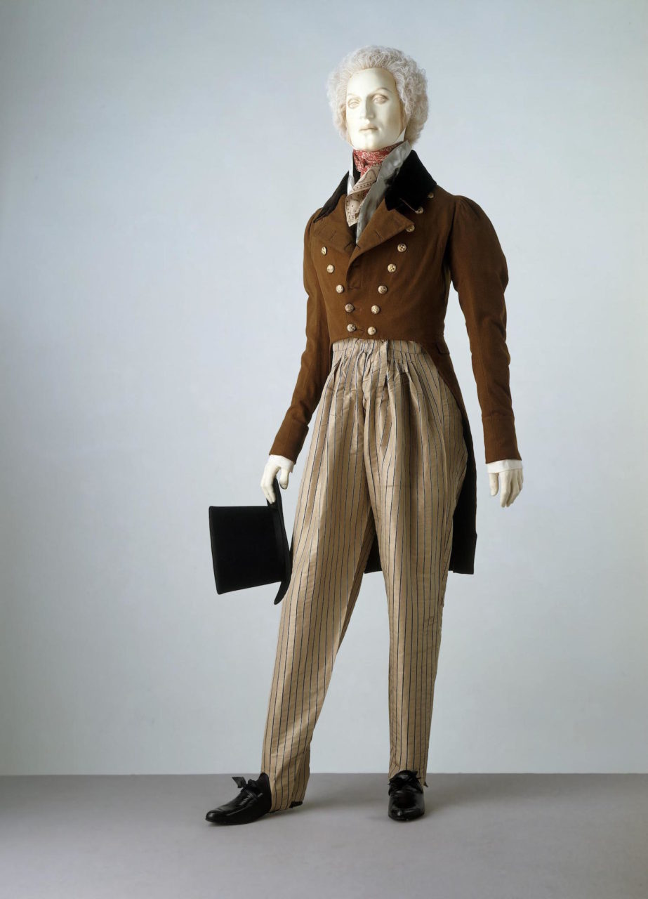

**Sources:**

Survey of Historical Fashion- page

<https://www.youtube.com/watch?v=4yuXYy02oXQ&t=1476>

1. Tunic Suit
2. Stock
3. Undersleeves
4. Victoria Sleeves

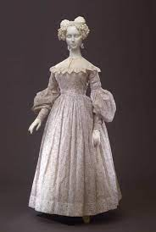

Throughout time the sleeve changes varied from being more fitted in the top arm, at the elbow, then at the wrist. Victorian day sleeves were mostly slim fitting which restricted the woman’s movements and lead to some of the mannerisms we know today of victorian women today. These sleeves were often set low on the shoulder

<https://fashion-era.com/romantic_era.htm>

Textbook 333

<https://maggiemayfashions.com/calicoball/fashionhistory/the-romantic-era-1820-1850/>

1. Waistcoat
2. Walking Dress
3. King George IV and Tartan Revival
4. Laced slippers
5. Makeup and health